TO SUPPLY LEFTOVER FOOD TO POOR

College Name: *PIONEER COLLEGE OF ARTS AND* *SCIENCE*

College Code: *4d*

**TEAM ID:**

**TEAM MEMBERS;**

**Team LeaderName**: ROJATHARAGINI S

**Email:**sevarajroja7@gmail.com

**Team Member1**: KAVIYA S

**Email:***kaviyasg2005@gmail.com*

**Team Member2:** RAMAN S

**Email:***ramanram093@gmail.com*

**Team Member3**: SATHYA G

**Email:***gsathya278@gmail.com*

**1.INTRODUCTION**

**1.1 Project Overview**

To supply leftover food to the poor this reduces food waste by collecting surplus food and distributing it to the poor using Salesforce. The platform streamlines the entire process, ensuring efficiency, transparency, and real-time tracking. It connects donors with recipients, creating a sustainable and accountable food redistribution system.

**1.2 Purpose**

The main objective of the project is to reduce food waste by collecting surplus food and distributing it to underprivileged communities efficiently and transparently.

**DEVELOPMENT PHASE**

**Creating Developer Account:**

By using this URL **-** [**https://www.salesforce.com/form/developer-signup/?d=pb**](https://www.salesforce.com/form/developer-signup/?d=pb)

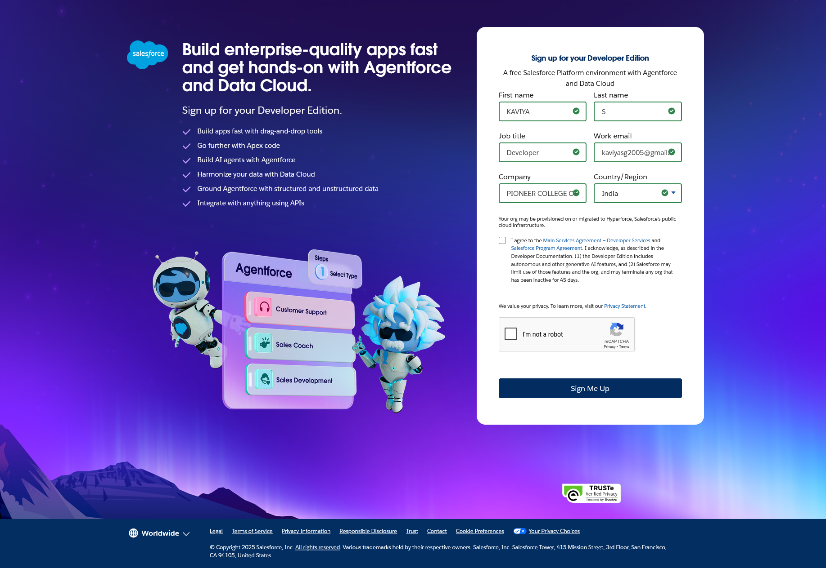

Account Activation:

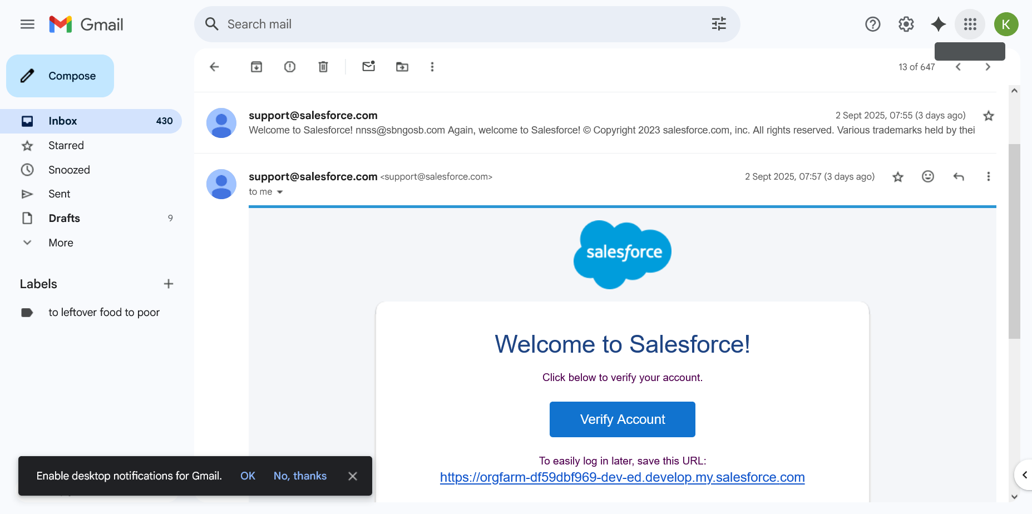

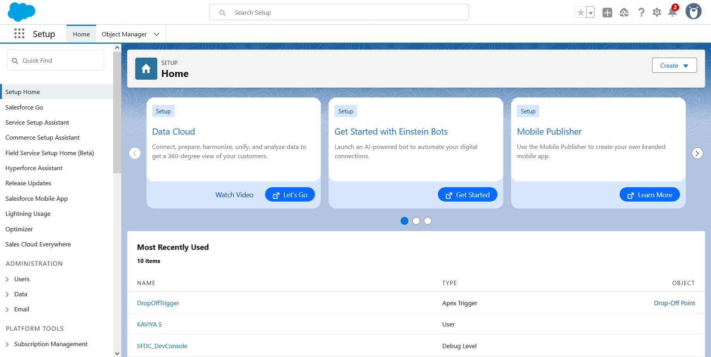

**●** Created objects**: Venue,Drop-Off Point,Task,Volunteer,**

**Execution Details**

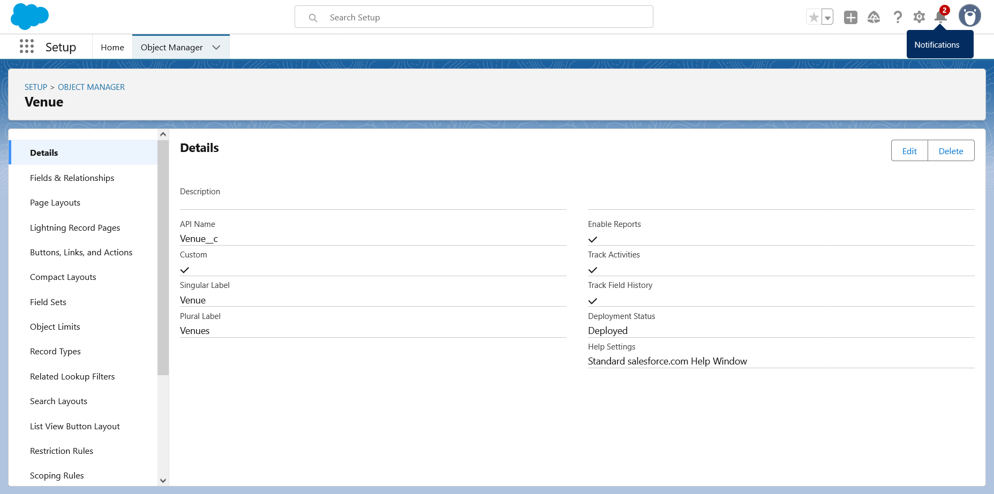

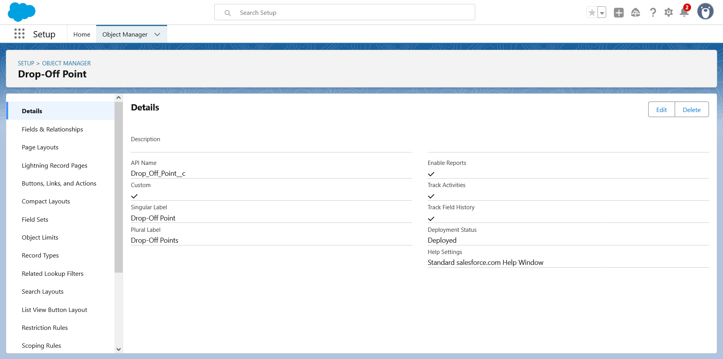

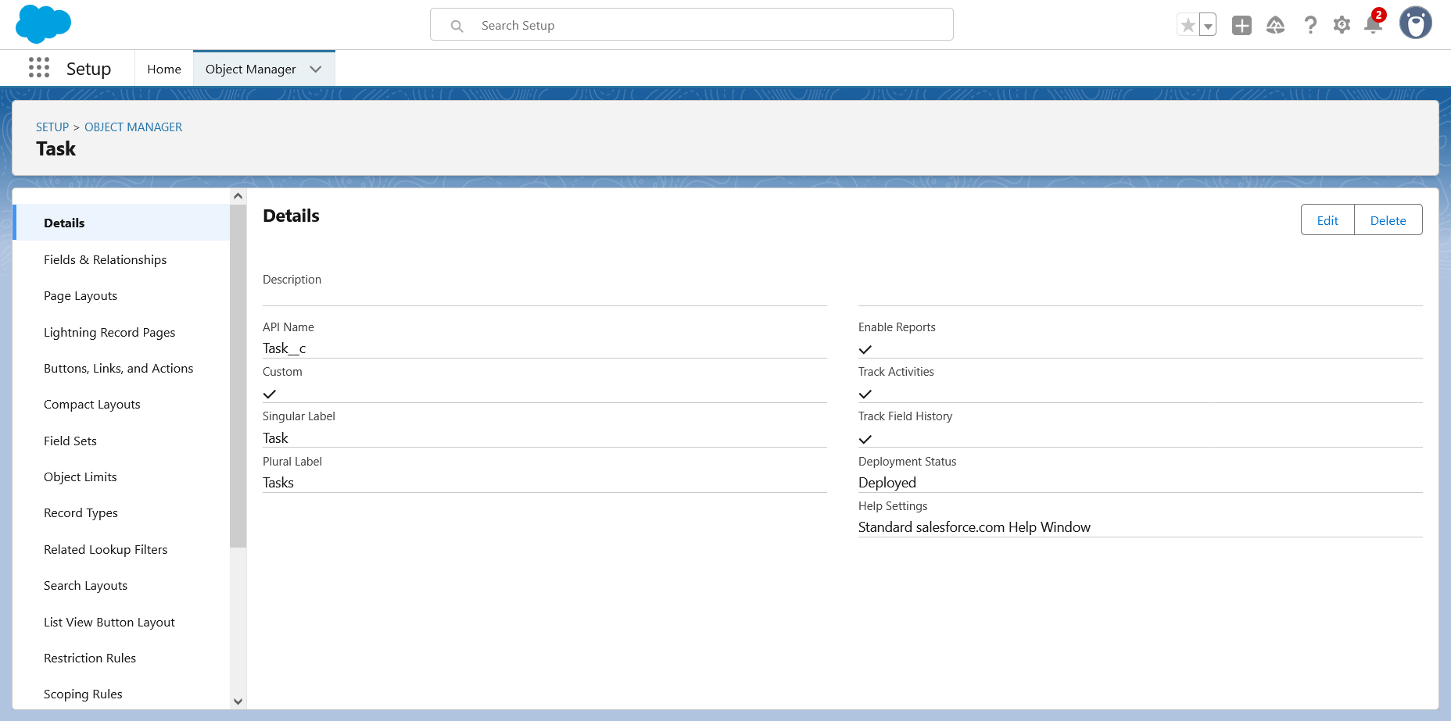

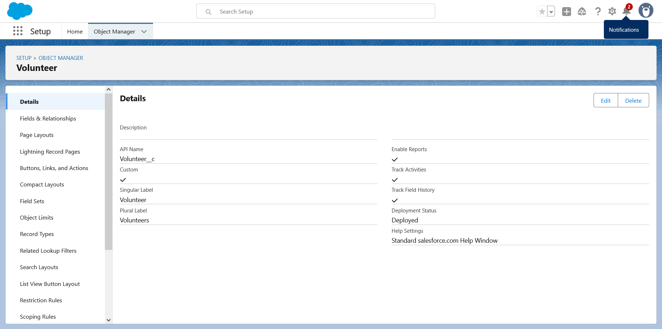

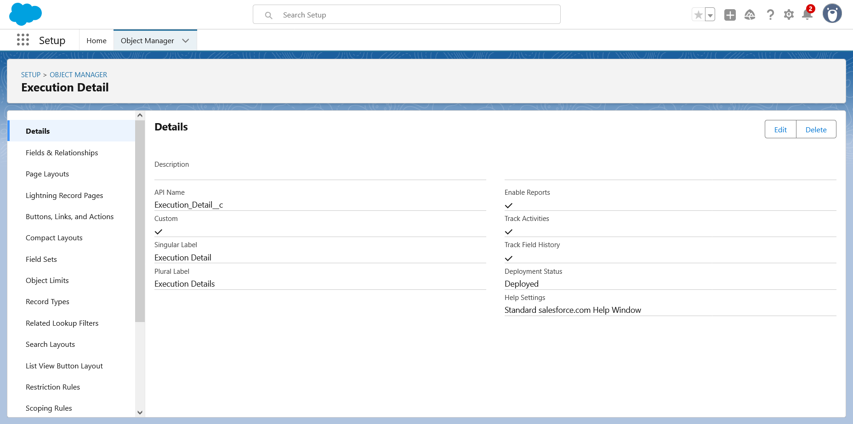

**●** Created Custom object tabs**: Venue,Drop-Off Point,Task,Volunteer,**

**Execution Details**

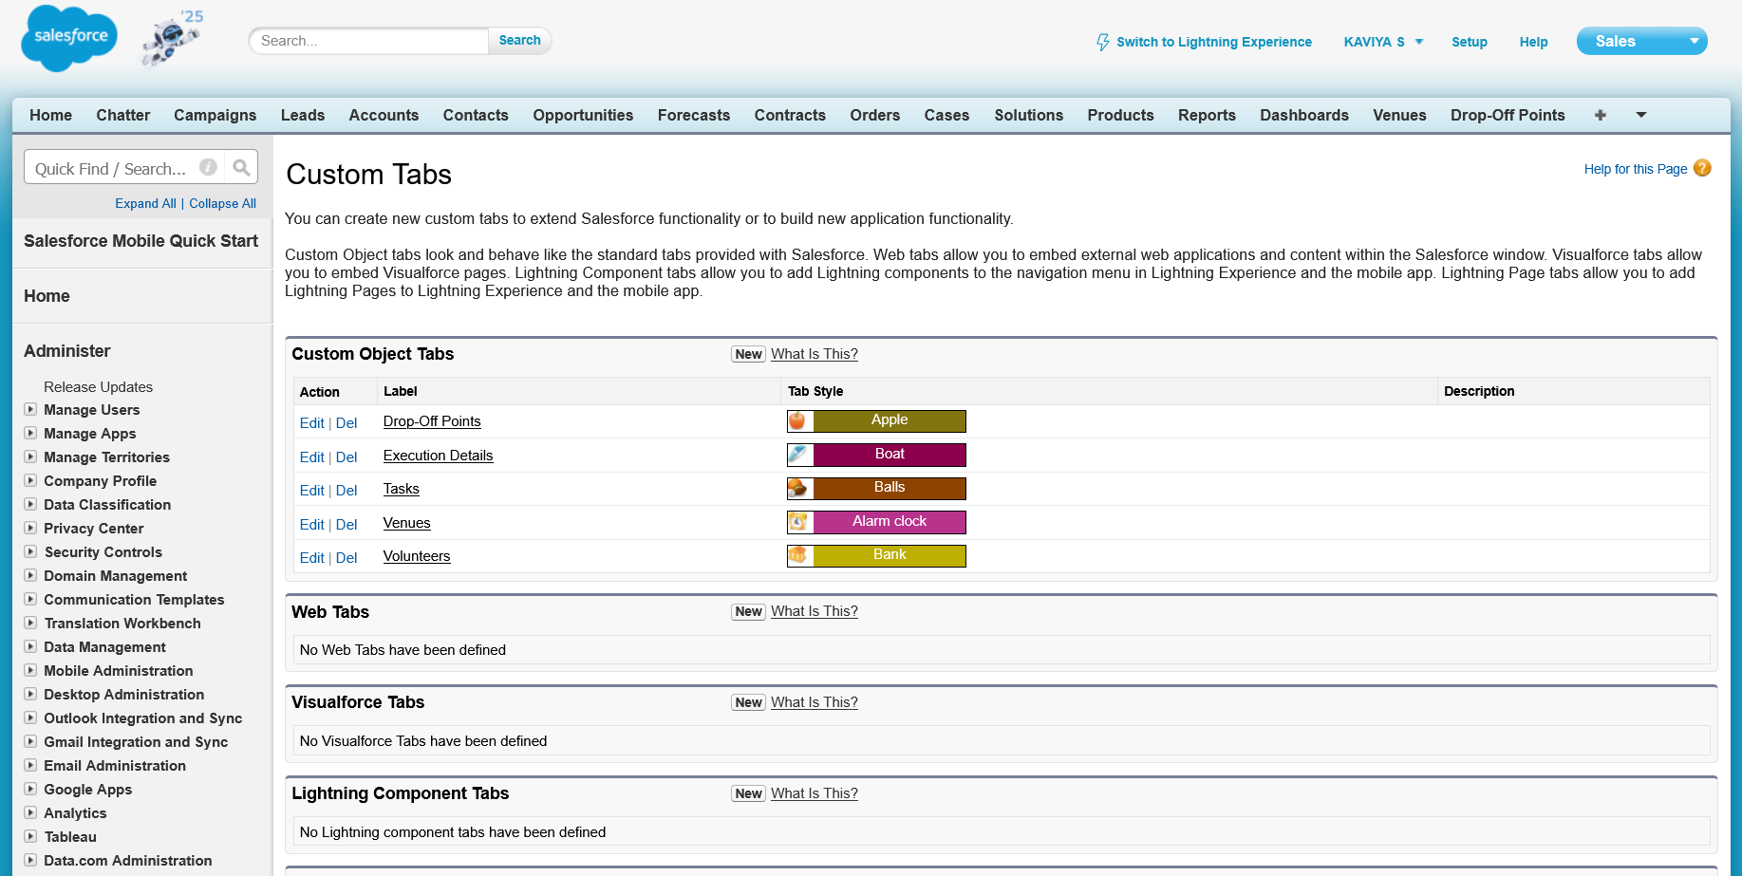

### **Created a Lightning App**

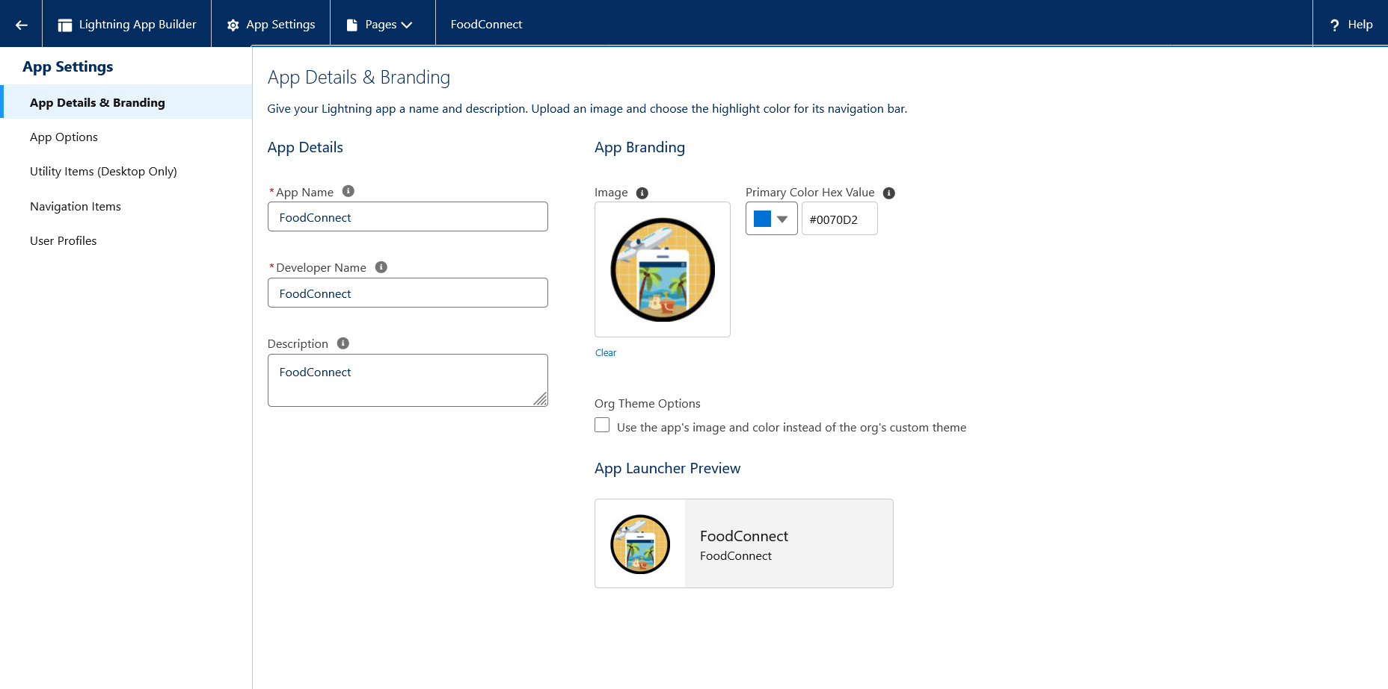

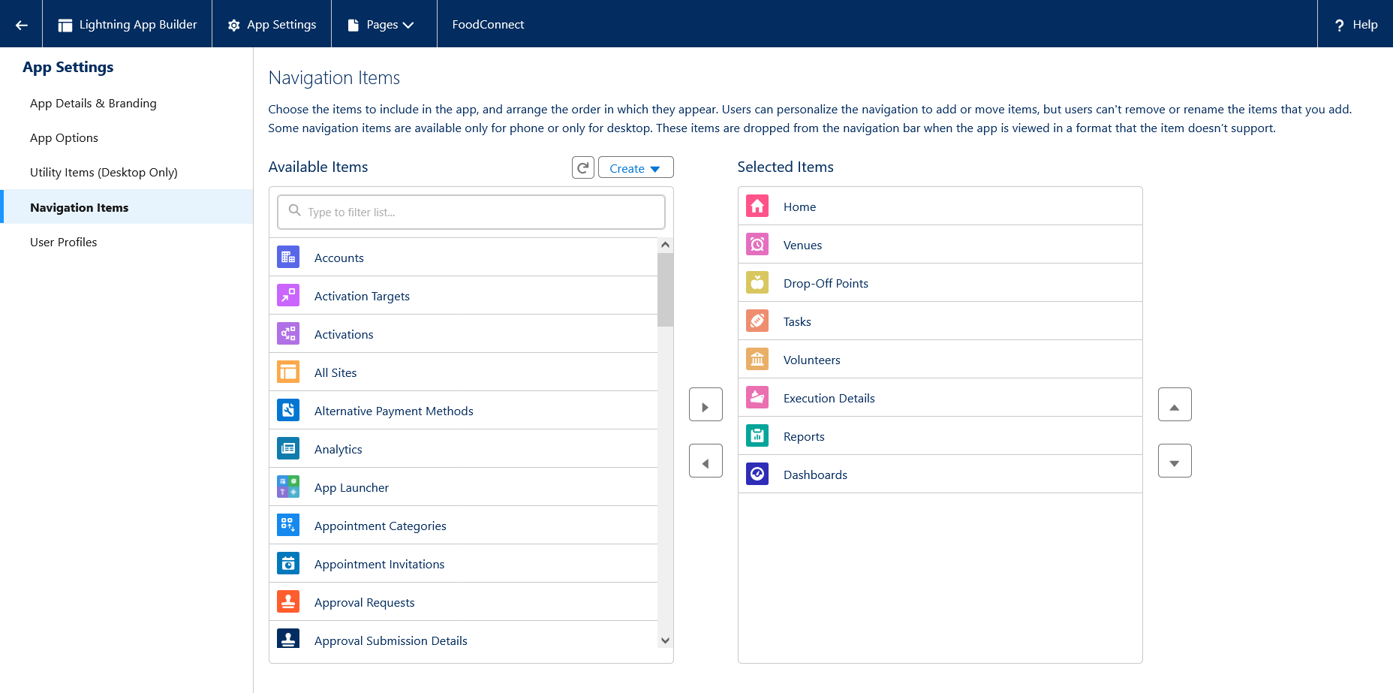

**Created fields for volunteers,venue,drop off points,task,execution details**

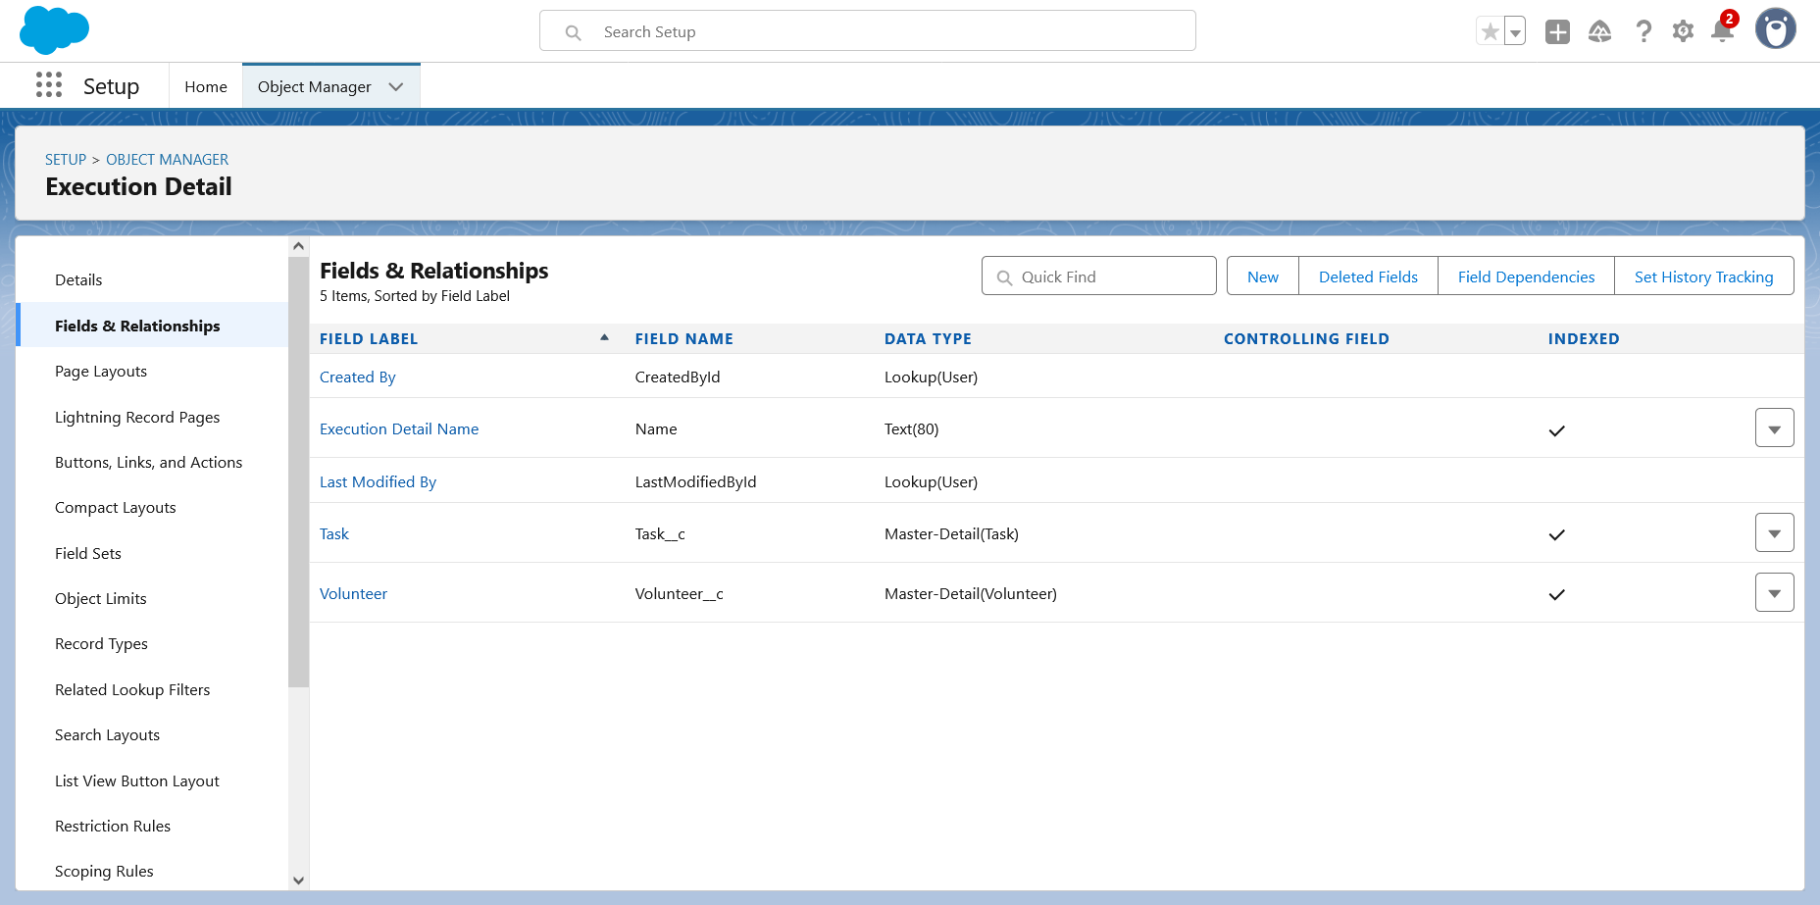

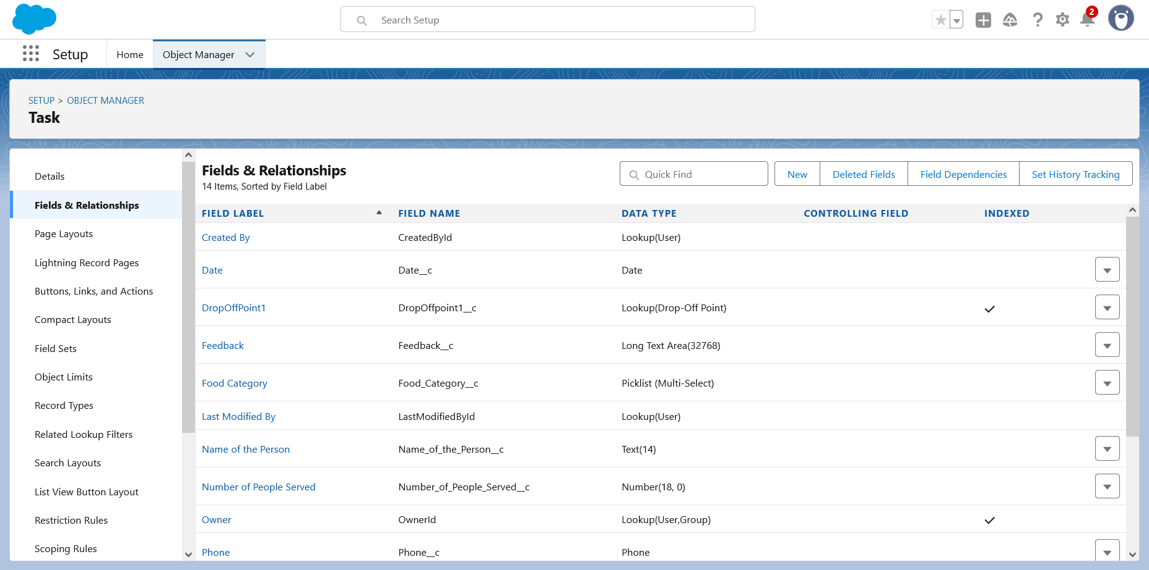

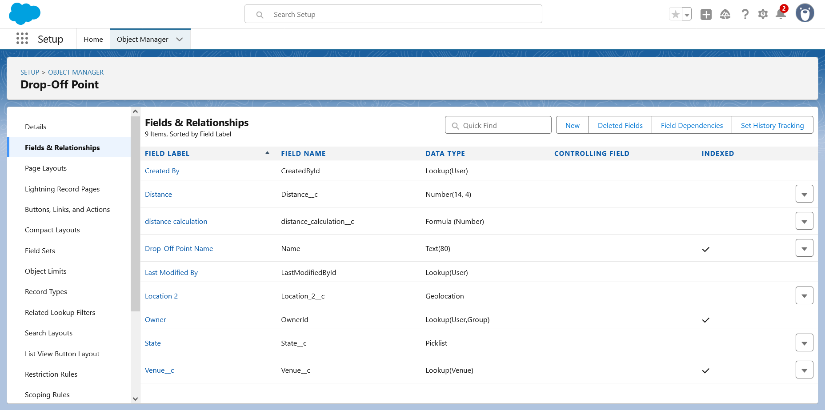

**Create Trigger**

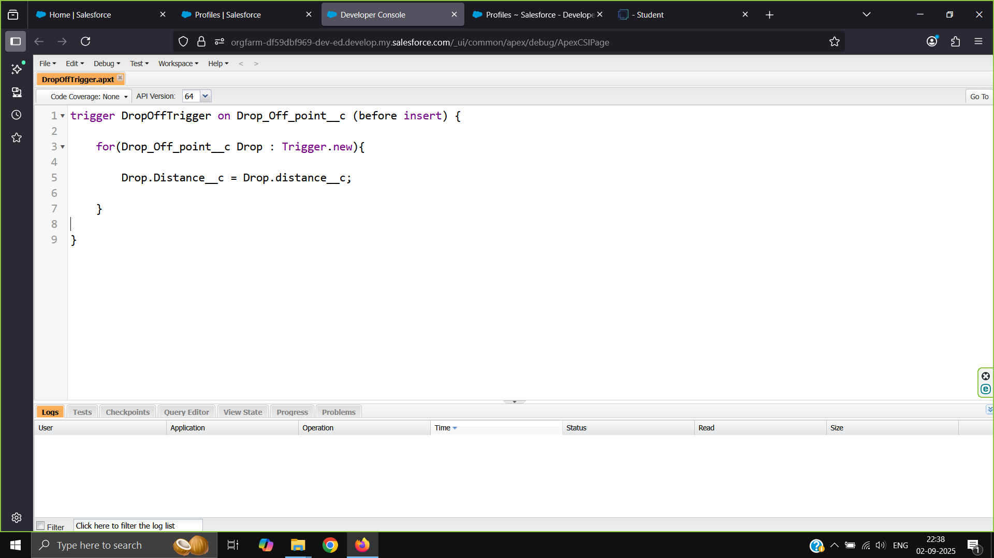

* **Create Flows**

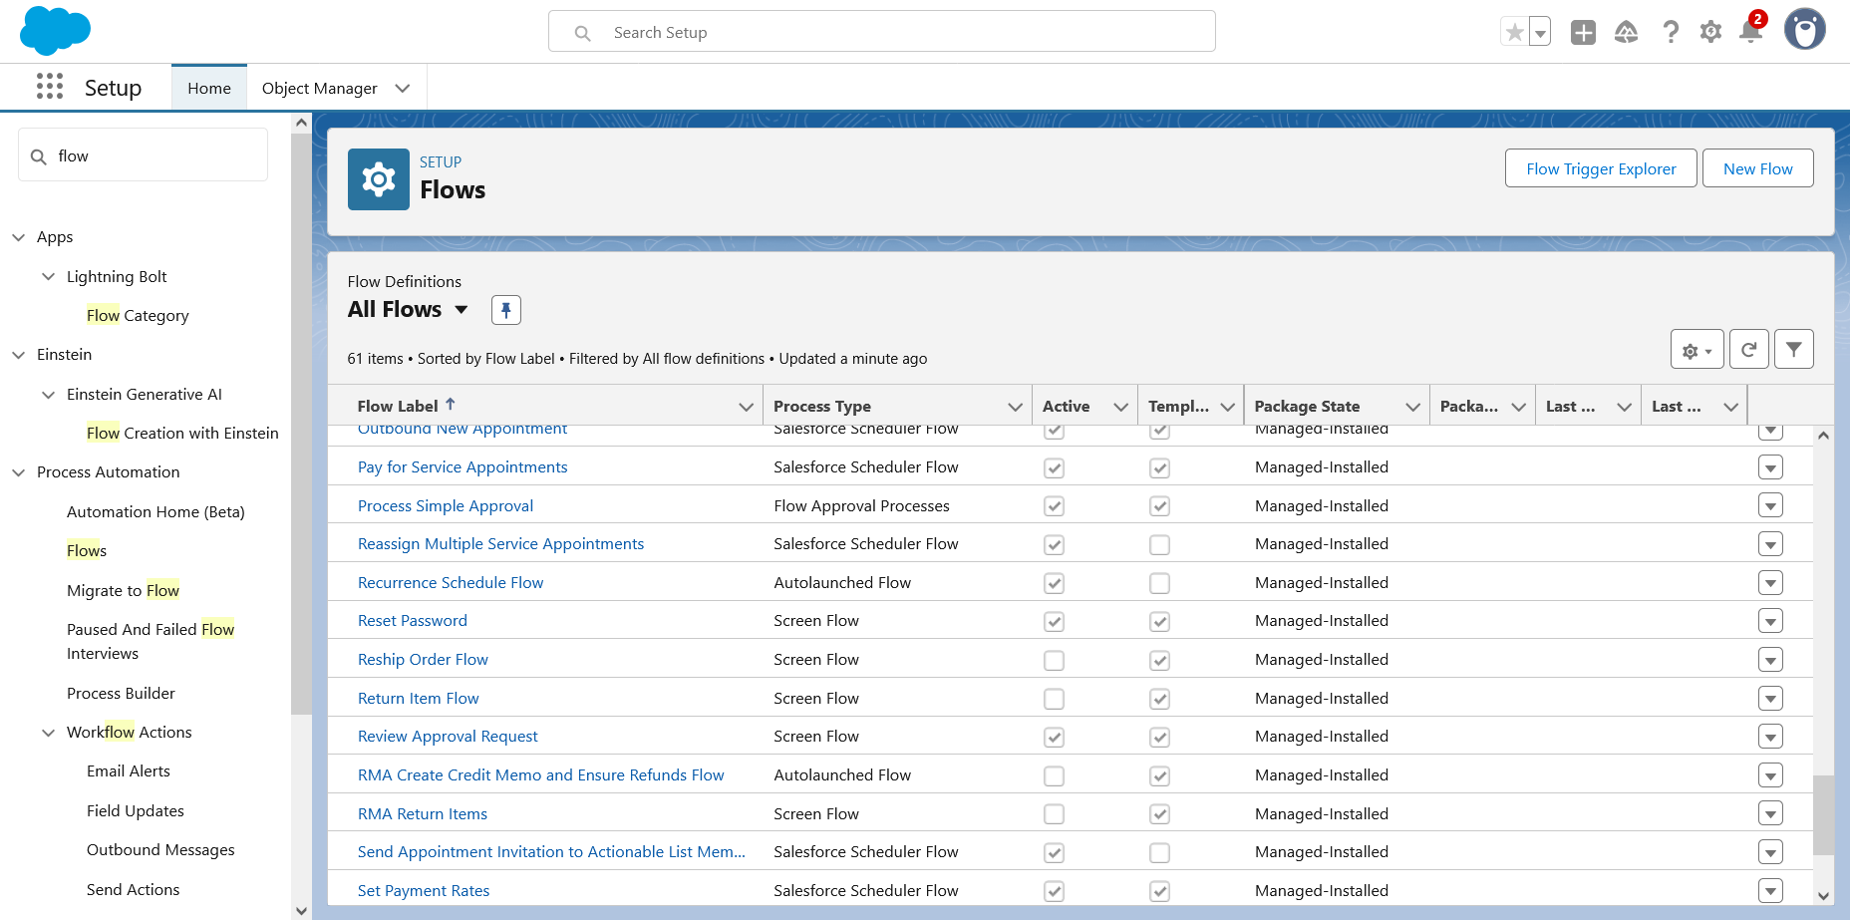

* **Created profiles**

### 

* **Created Users**

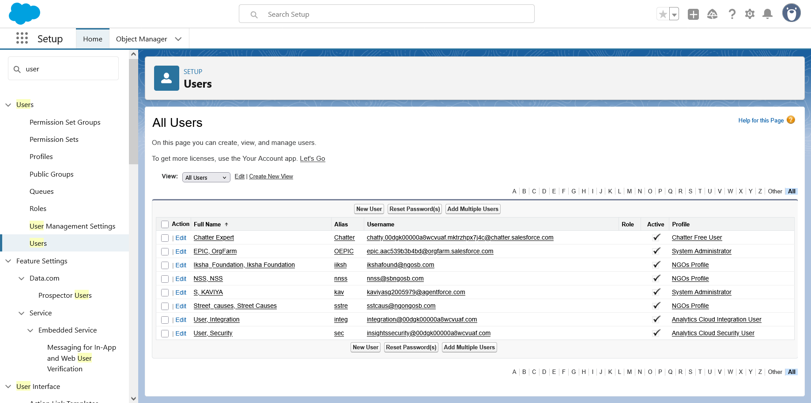

* **Created a Public Groups**

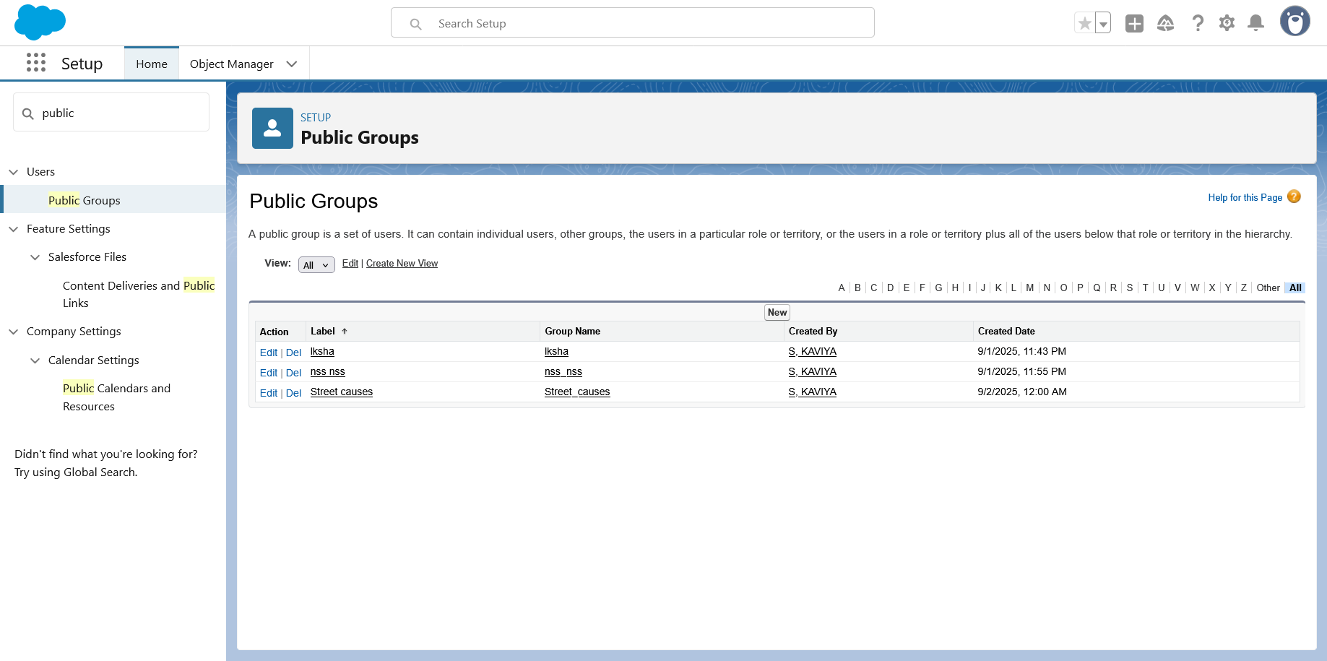

### **Created a Report Types**

### 

* **Created a reports**

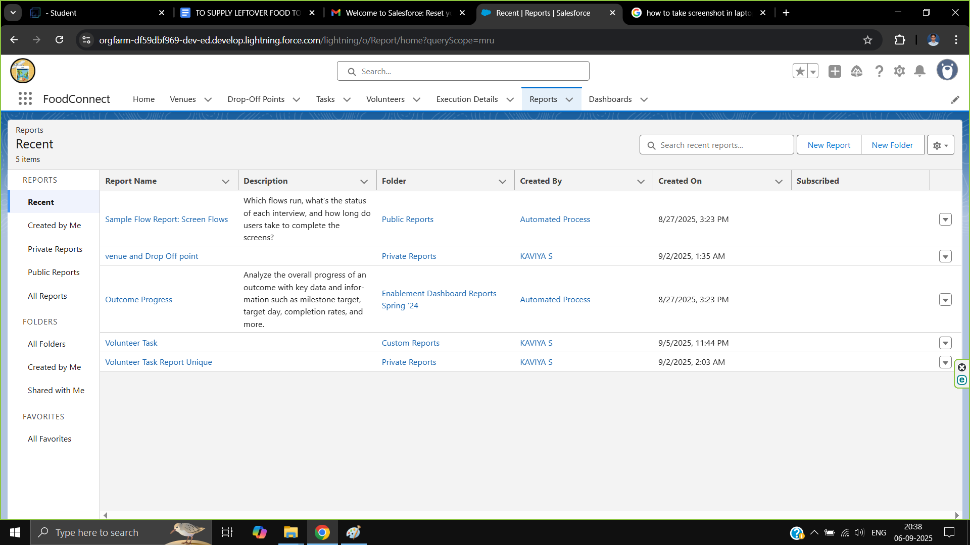

* **Created a Dashboards**

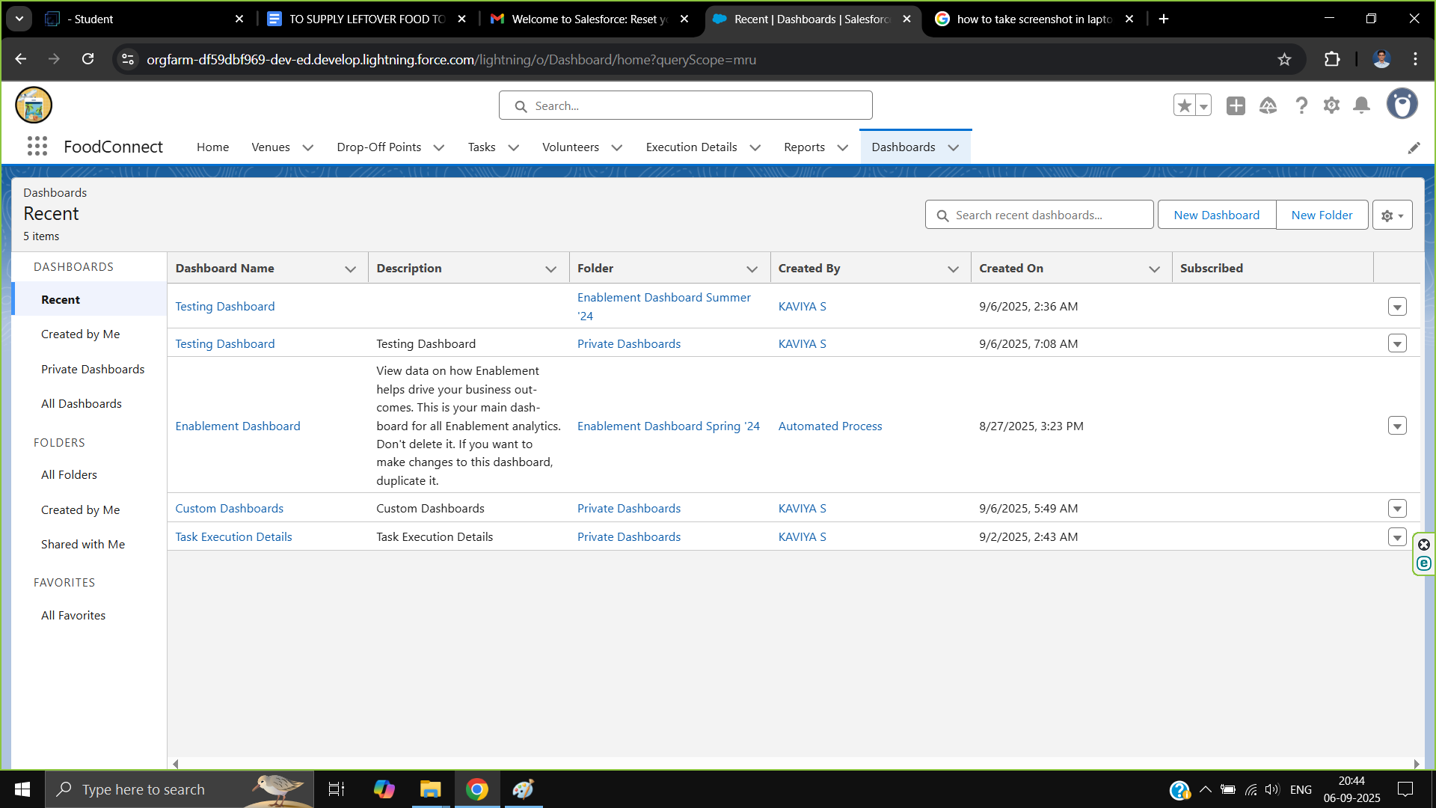

* **Created Sharing Rules**

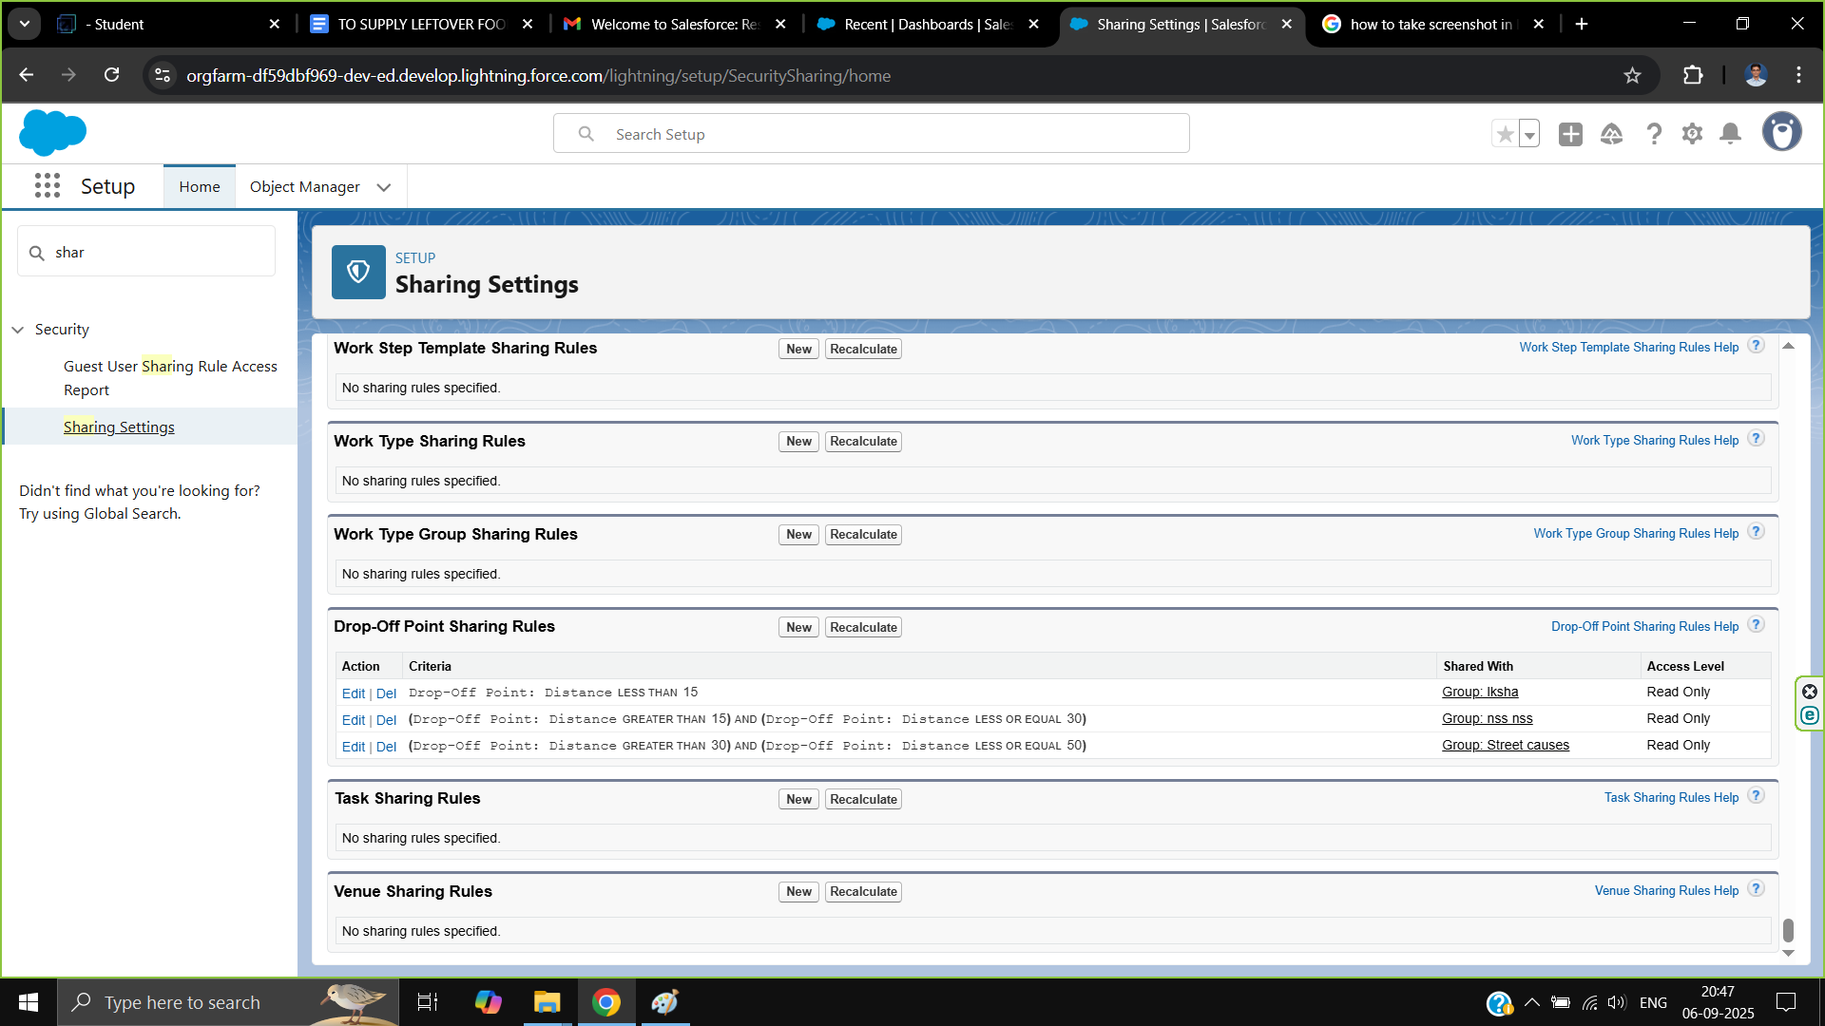

* **Created a HOMEpage**

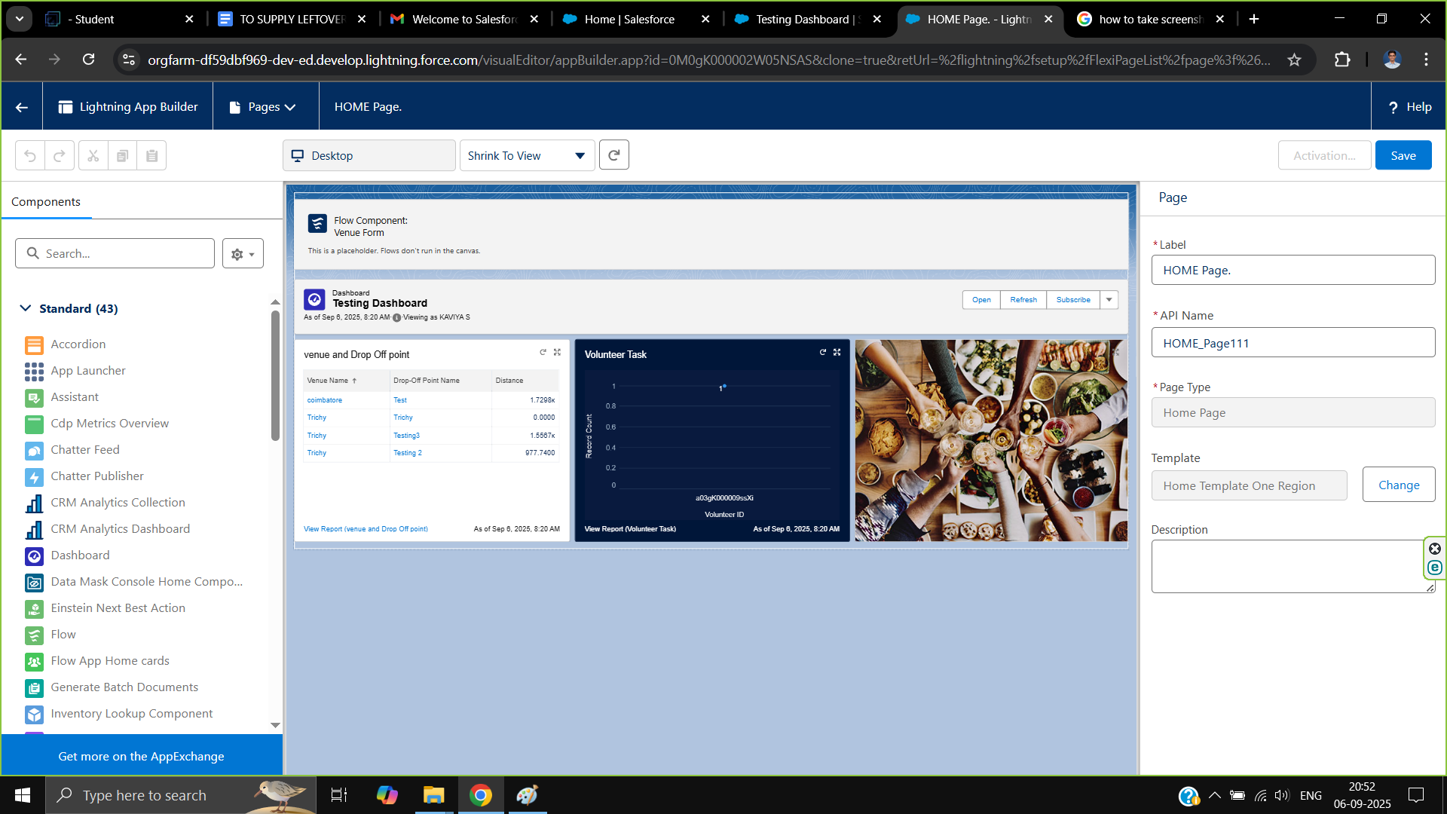

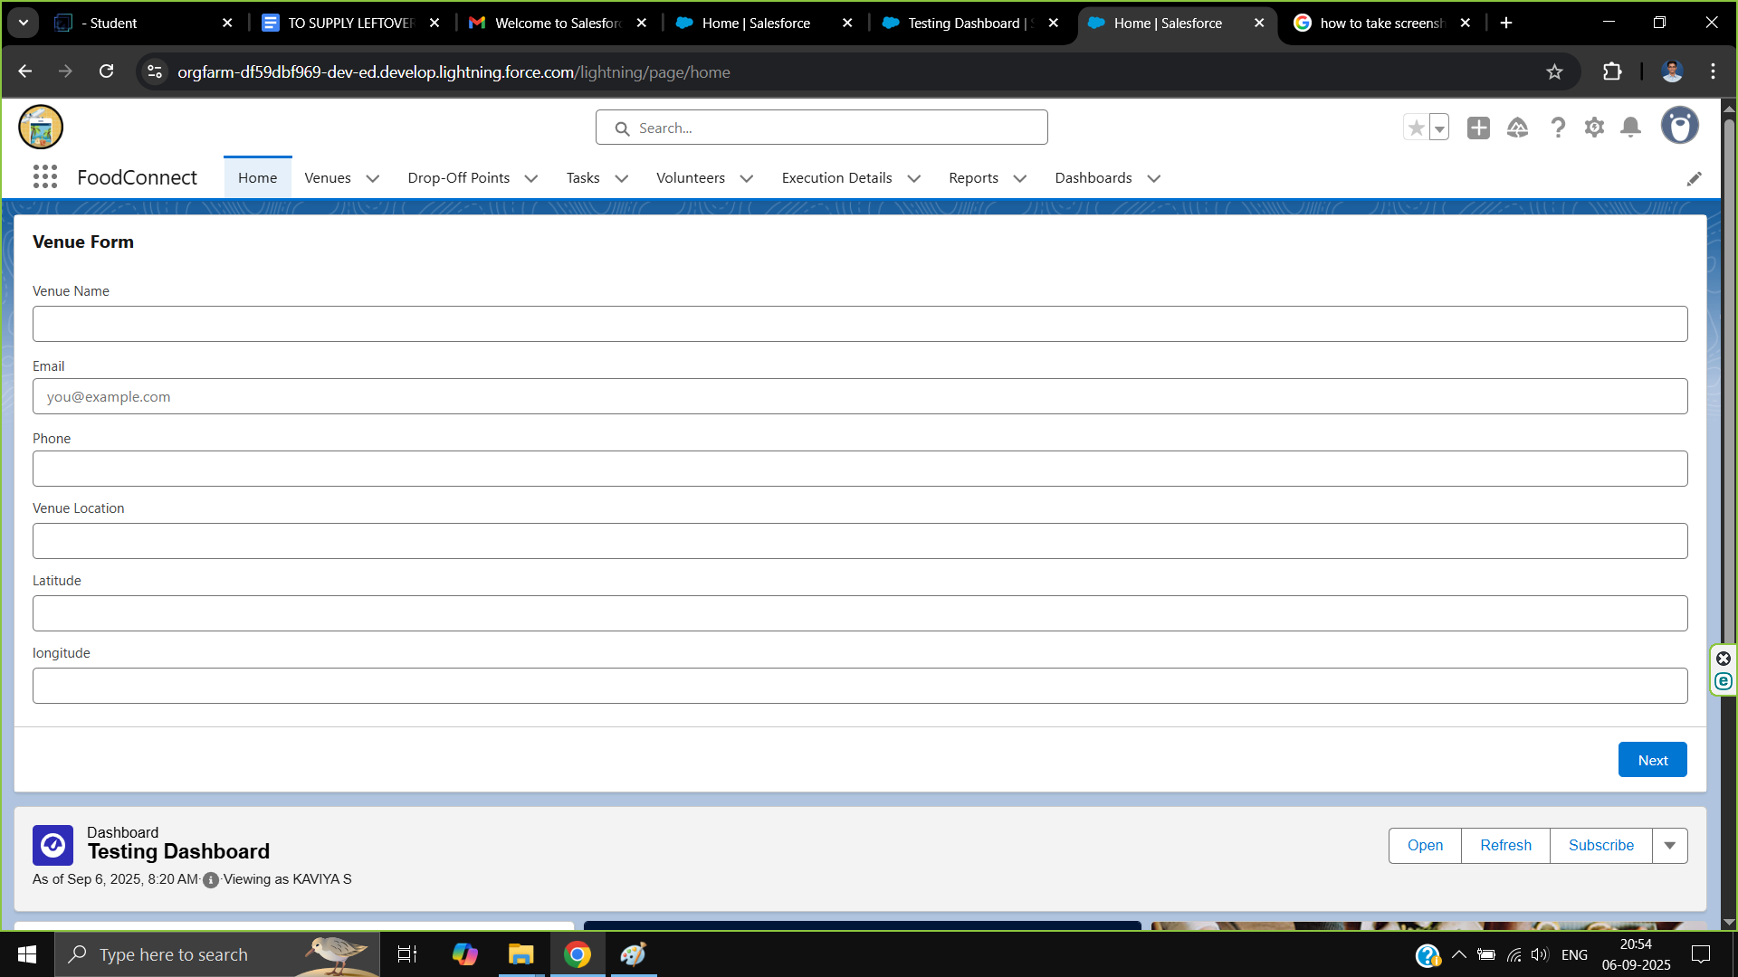

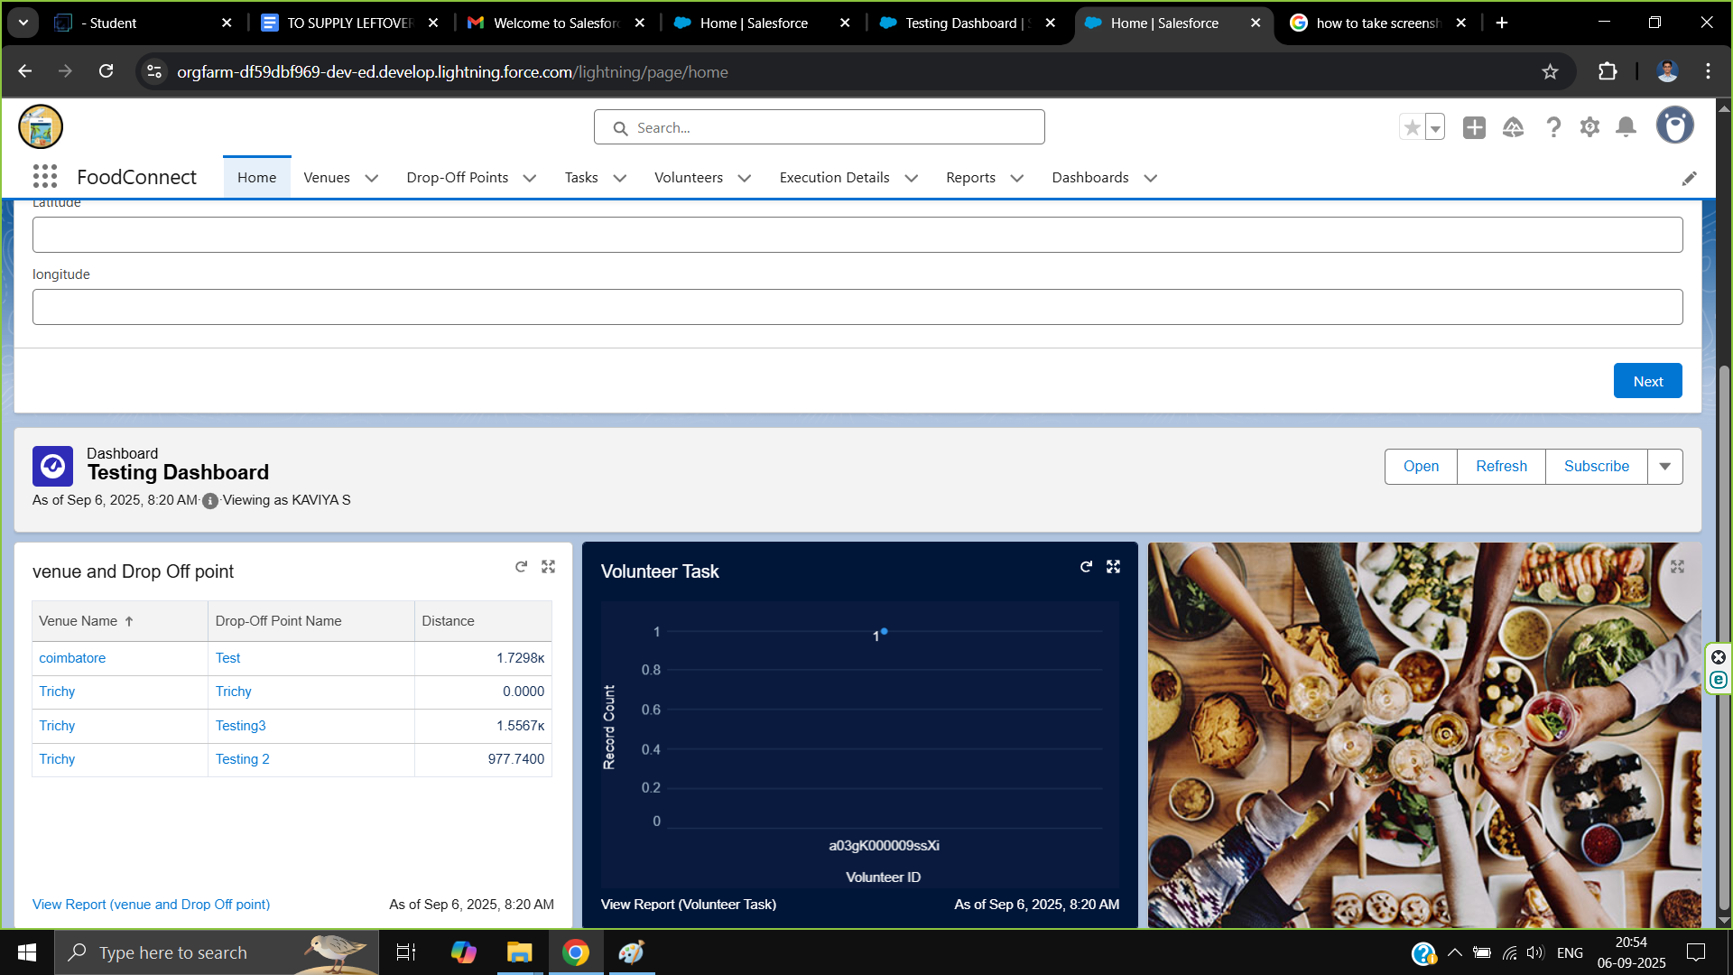

### ***Conclusion***

***By leveraging the Salesforce platform, the project successfully established a streamlined and transparent system for managing surplus food donations. Through efficient coordination with volunteers and timely delivery to beneficiaries, the project effectively addressed food insecurity while maximizing the utilization of available resources*.**